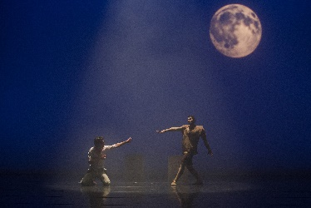
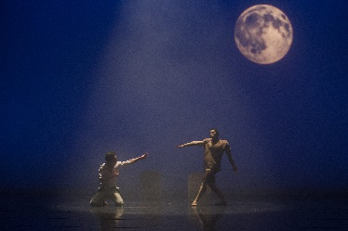
Frankenstein 2020
Registration Form
Dancer’s Name: |  |  |  |  | Audition Times(s):
Age: | Grade: |  | DOB: |  | MBT Level: |  | Tee Shirt Size:
Street Address: |  |  |  | City: |  | State, Zip:
Parent/Guardian Name(s):
Mother’s Email: |  |  |  | Father’s Email:
Mother’s Phone: |  |  |  | Father’s Phone:
Is text okay? Yes No |  |  |  | Is text okay? Yes No
Home Phone: |  |  |  | Emergency Contact Name:
Student’s Cell Phone: |  |  |  | Emergency Contact Phone:
Student’s Email:
Location of Previous Training:
How many years & what classes:
How did you hear about MBT?
Audition Fee: $20 |  | Date Paid: |  | Payment Method:

Level | Production  Fee Amount | Tee Shirt  $30 each | DVD  $35 each | Total Amount  Due | Amt. Paid | Date Paid | Method of Payment
Beginner | $150
Intermediate | $200
Advanced/Solo Role | $250
Late Fee  (if applicable) | $25

ALL PRODUCTION FEES ARE NON-REFUNDABLE AND NON-TRANSFERRABLE _________ Please Initial

Director’s Notes:

