Audition Notice

**Friday, August 18th**

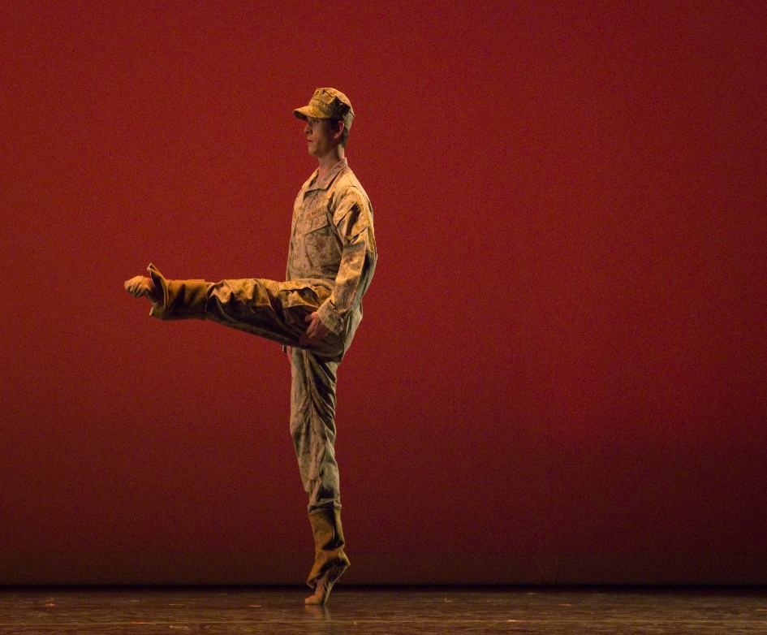

**Manassas Ballet Academy**

**9004 Mathis Avenue**

**Manassas, VA 20110**

|  |  |
| --- | --- |
| **4:00 - 5:00 pm** | **Boys & Girls Age 5 & Up** |

***Please arrive 15 minutes prior to your audition time.***

* The audition fee is $20. Audition registration forms are available at the MBA studio front desk and online at [www.manassasballet.org](http://www.manassasballet.org). Completed forms and audition fee payments are due before the audition.
* Cast list & rehearsal schedule will be posted and emailed Tuesday, August 22.
* Production fees are due no later than Monday, September 25, 2023. Production fees received after this will be charged a $25.00 late fee. Production fees that are not received by Monday, October 2, 2023 will result in your dancer being dropped from the production.
* **Performance Location & Dates:**

**Location:** Hylton Performing Arts Center, Manassas, VA

**Dates:** Thursday November 9 & Friday, November 10 @ 7:30 & Saturday, November 11 @ 3:00

**For more information:** [**info@manassasballet.org**](mailto:info@manassasballet.org) **or (703) 257-1811 or 703-368-6621**